Artist
The Google Dolls
The Goo Fighters
G's N' Roses
Alice Googler

Merch
T-shirt
Longsleeve
Tour Movie
Digital Album
CD

Album
Live
Greatest Hits

Carrier
CD
Digital Album

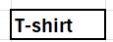 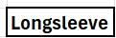 Longsleeve

ShirtSize
XS
S
M
L
XL
2XL
3XL

